TASK 1 – Identify the rooms in the office plan. (<https://ieltstrainingonline.com/ielts-listening-recent-actual-test-with-answers-practice-test-01/> listen to the second half of audio “SECTION 2” to solve the task).

1. D   Local Tours
2. F Interstate Tours
3. B International Tours
4. C  Asian Region
5. A General Office

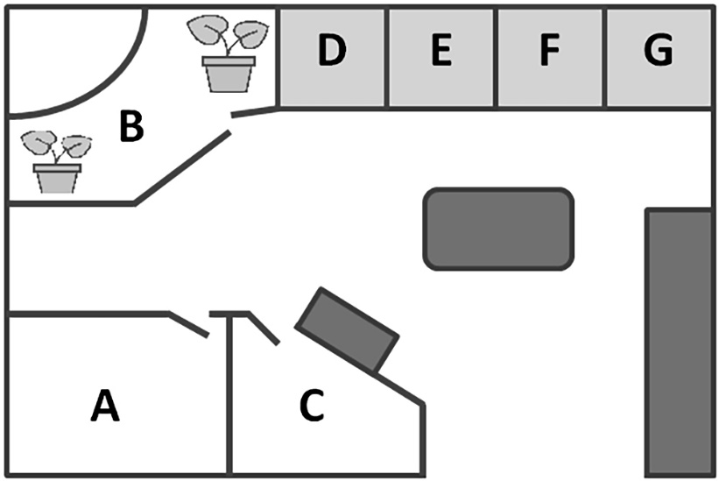

TASK 2 - Complete the labels (25-30) by writing **ONE WORD OR A NUMBER** for each answer. (<https://ieltstrainingonline.com/ielts-listening-recent-actual-test-with-answers-practice-test-01/> listen to the second half of audio “SECTION 3” to solve the task)

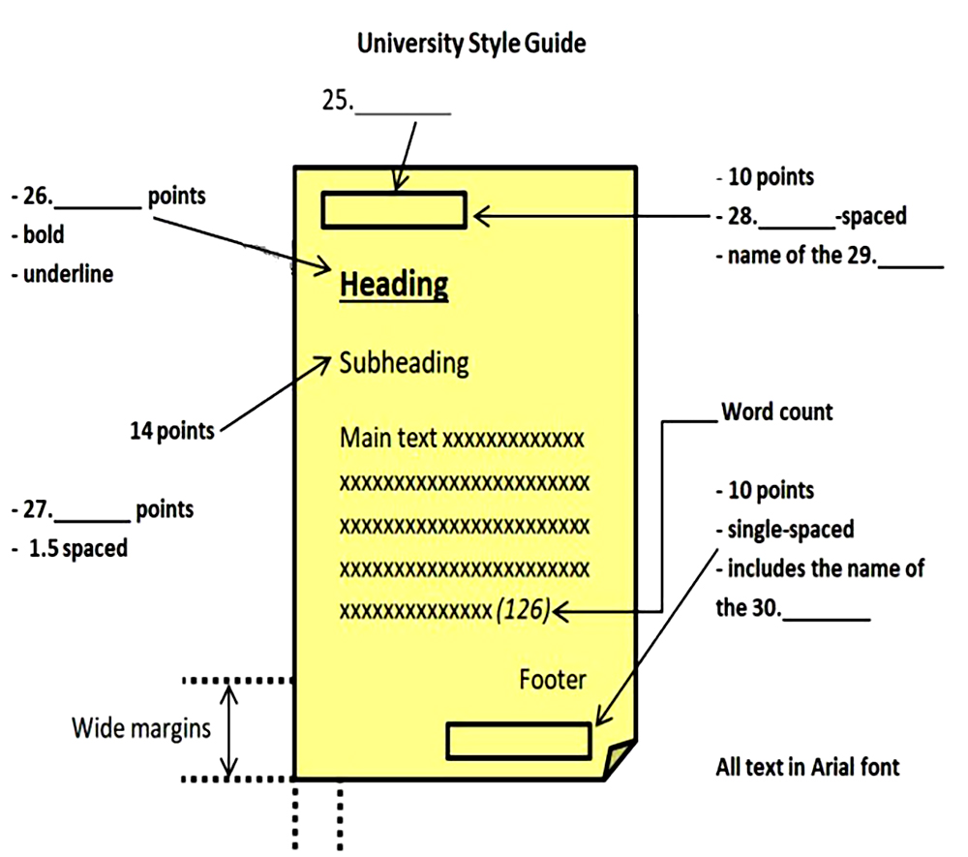

25.Header

26.16

27. 12

28.Single

29.Work

30. Teacher

TASK 3 - Complete the flowchart by writing **ONE WORD** for each answer. (<https://ieltstrainingonline.com/ielts-listening-recent-actual-test-with-answers-practice-test-02/> listen to the first half of audio “SECTION 3” to solve the task)

**Foundation for Essay Writing**

Decide on **1. Topic** you like.

↓

Focus on **2. Break** area of interest.

↓

Write **3. Thesis** statement.

↓

Create **4. Outline**

↓

Ensure this **5. Progress** clearly.

TASK 4 – Label the floor plan. (<https://ieltstrainingonline.com/ielts-listening-recent-actual-test-with-answers-practice-test-04/> listen to the first half of audio “SECTION 2” to solve the task)

**1.A**   Quiet reading

**2.E**  Computers

**3.D**   Newspapers & magazines

**4.F**   Reference books

**5.C**   Audio section

**6.B**   Main library

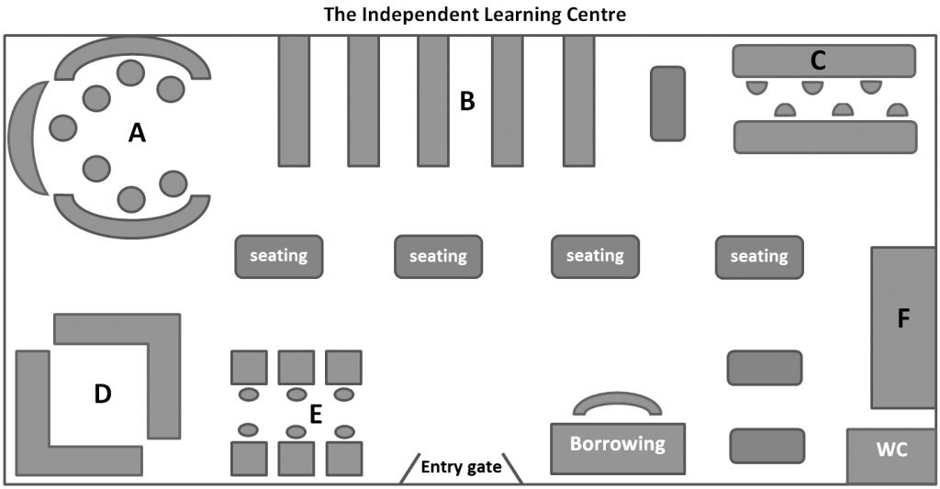

TASK 5 - Complete the diagram (36-40). Write **NO MORE THAN TWO WORDS AND/OR NUMBERS** for each answer. (<https://ieltstrainingonline.com/ielts-listening-recent-actual-test-with-answers-practice-test-04/> listen to the second half of audio “SECTION 4” to solve the task)

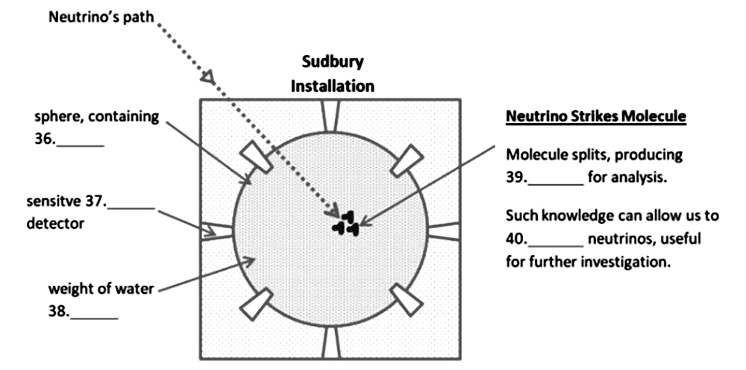

36.Water

37.Electronic

38.1000 tones

39.Electric current

40.Control